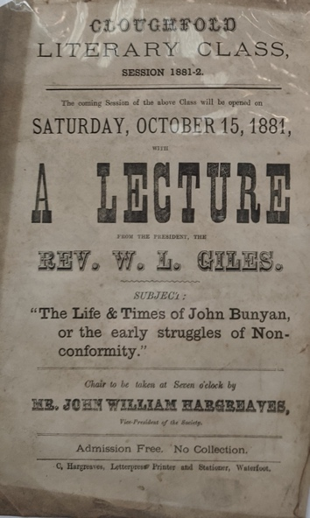

CLOUGHFOLD
LITERARY CLASS
SESSION 1881-2

The coming Session of the above Class will be opened on

SATURDAY, OCTOBER 15, 1881
WITH
A LECTURE
FROM THE PRESIDENT, THE
REV W.L. GILES.
SUBJECT
“The Life and times of John Bunyan,
or the early struggles of Non-
conformity

Chair to be taken at Seven o’clock by

Mr JOHN WILLIAM HARGREAVES
Vice-President of the Society

Admission Free. No Collection

C. Hargreaves, Letterpress Printer and Stationer, Waterfoot.

